

SNF RRAM Process

Standard Operating Procedure

Akash Levy, Jung-Soo Ko

ENGR 241 Winter 2020 Report

# Introduction

The motivation of this project is to develop a simple and robust resistive random-access memory (RRAM) process carried out entirely in SNF/ExFab without reliance on external tools. RRAM is a current topic of research for many research groups at Stanford and across the world. A well-characterized and documented standard process flow along with a set of standard layouts would accelerate research significantly, especially for newcomers to SNF or RRAM research at Stanford.

This project is just getting started. So far, we have developed a first version of the layouts, and have produced one wafer with a small number of working devices. The yield is currently very low; of the 20 cells tested, only 2 showed reproducible bipolar switching behavior. We have not performed endurance or retention tests yet. We plan to continue this project beyond this quarter to achieve better device characteristics and improve yield. We also will provide statistical validation across multiple wafers once the process flow has been optimized.

The aim is for the RRAM cells to ultimately match/exceed specifications of state-of-the-art devices reported in literature; more specifically, the peak ON/OFF ratio (ratio of ON current to OFF current) of the RRAM should be maximized (10x is acceptable, 100x is good, 1000x is excellent), the FORM/SET/RESET voltages should be close to modern CMOS operating voltages (1-3 Volts), retention should be 10 years at room temperature, endurance should be > 106 cycles, and yield should be > 95% (hopefully > 99%). Some examples of devices reported in literature which achieve these goals are logged on the [Stanford Memory Trends](https://nano.stanford.edu/stanford-memory-trends) webpage.

Over the course of this quarter, we were able to produce one 4-in wafer with a small number of working two-terminal RRAM cells that exhibit reproducible resistive switching. Each cell consists of a HfO2 resistive switching layer, a Pt bottom contact, and a TiN top contact that induces the resistive switching phenomenon through the generation of oxygen vacancies. There is no integrated selector device (i.e. transistor, diode), nor is there any sort of integrated resistor. We have included the working device characteristics at the end of this report, and we also discuss possible strategies for improving the devices’ electrical characteristics. A full community service proposal for future work on the process flow will be written soon.

**All data and scripts for processing the data are available here:** [**https://github.com/akashlevy/ENGR241-Q2**](https://github.com/akashlevy/ENGR241-Q2)

# Process Flow

## High-Level Diagram



## Detailed Process Steps

1. Obtain Si wafer and perform RCA clean wafer
   1. Type of wafer does not matter, other materials (e.g. glass) should also work
   2. The cleaning process is well documented: [Wet Bench Clean](https://snfexfab.stanford.edu/snf/operating-instructions/wet-bench-clean1and2), [Training Video](https://www.youtube.com/watch?v=jL4RJ1gMZ-M&feature=youtu.be)
2. (Optional) Grow at least 50nm SiO2 with thermco
   1. This layer is recommended for electrical isolation of bottom contact and Si bulk
      1. May help prevent ESD problems
   2. Recommended method: 20 min. of 900˚C wet growth
   3. WETOX recipe with default settings and time/temp from above
   4. Exact thickness is not important, make sure at least 30nm is grown
3. Use Woollam or Nanospec to check oxide thickness
   1. Use recommended settings from [Woollam In-Depth](https://snfexfab.stanford.edu/snf/operating-instructions/woollam-ellipsometer-in-depth)
   2. 1mm Si layer, 50nm SiO2 layer, fit SiO2 layer, n-k fit should not be necessary
4. Deposit 10nm Ti: AJA-Evap
   1. Recommended recipe: Ti 0.5Å/s, 10nm
   2. Note: this should be done in Lesker-2 from now on to stay in cleanroom
   3. Exact thickness is not important
5. Deposit 30nm Pt: AJA-Evap
   1. Recommended recipe: Pt 1Å/s, 30nm
   2. Note: this should be done in Lesker-2 from now on to stay in cleanroom
   3. Exact thickness is not important
6. Deposit 150nm SiO2: ccp-dep
   1. Recipe: SiO350-0, SiOx1 @ 350˚C, 2.5 min
   2. Exact thickness is not important
7. Woollam to check SiO2 thickness
   1. Use recommended settings from [Woollam In-Depth](https://snfexfab.stanford.edu/snf/operating-instructions/woollam-ellipsometer-in-depth)
   2. 1mm Si layer, 10nm Ti layer, 30nm Pt layer, 150nm SiO2
   3. Measure 65-75 degrees, n-k fit for SiO2 because it may not be stoichiometric
   4. Record n-k fit for SiO2 for use in step 15
8. Photolithography
   1. YES Oven default recipe
      1. Recommended for vapor prime, supposedly better than SVG coat HMDS
   2. SVG Coat 1 or 2
      1. Be sure to run a dummy wafer first
      2. Recipe: 1µm Shipley 3612 resist, 2mm EBR, skip vapor prime step
   3. Expose with Heidelberg 1 or 2
      1. Only Heidelberg2 currently has the designs already stored
      2. For Heidelberg1, you can load the design from the layer0_fixed_scaled.dxf in the [GitHub repository](https://github.com/akashlevy/ENGR241-Q2)
      3. Design: akashl_rram_layer0_scaled
      4. Recommended Defocus: -2
      5. Recommended Dose: 80 for Heidelberg1, 70 for Heidelberg2
      6. Recommended Laser Source: 350nm
      7. Try to center design if possible
   4. SVG Develop 1 or 2
      1. Be sure to run a dummy wafer first
      2. Recipe: Post-exposure bake
      3. Recipe: 1µm Shipley 3612 develop
9. Oxide etching of trenches: PT-Ox
   1. Recipe: Ox_ER_Test, 210 sec.
   2. This should be enough to etch down to the Pt layer
10. Resist ashing: Matrix
    1. Recommended: default recipe (Nancy1 Strip.rcp)
11. Metal cleaning on wbflexcorr (1)
    1. SRS-100 for [stripping photoresist from metal wafers](https://docs.google.com/document/d/e/2PACX-1vRfd5BxH0u22xoMtiLu3S16gvbFtYoo4H3x5QLuRKrO8Zx_K7MJCzcoT4pUJ2KeorcmlBSPN2T4TMqY/pub), 60˚C, 15 min
    2. PRS-1000 for [final metal clean before deposition](https://docs.google.com/document/d/e/2PACX-1vQVrNtPxQQrxWfnSRrWFPW6J91AlmBdPehf2V-pV_beCoSDluY7y16DNZp7VRrlE7GDCxfF3EnTlmk3/pub), 40˚C, 10 min
    3. Get training from Uli specifically for these procedures
12. Alphastep to check etching
    1. First look under microscope to make sure trenches are visible
    2. Compare Alphastep measurement to Woollam measurement from step 7
       1. These results should produce matching numbers
13. (Optional) Perform SC-1 clean on wbflexcorr
    1. This should be done if there is any delay between metal cleaning and ALD step
    2. The cleaning process is well documented: [Wet Bench Clean](https://snfexfab.stanford.edu/snf/operating-instructions/wet-bench-clean1and2), [Training Video](https://www.youtube.com/watch?v=jL4RJ1gMZ-M&feature=youtu.be)
14. ALD of resistive switching layer: Fiji (1/2/3)
    1. Recipe: Standard Thermal Hafnia
    2. Thermal is recommended because plasma may introduce interface traps
    3. Temperature: 200˚C
    4. Recommended: condition chamber with above recipe for 50 cycles
    5. Deposition should be 50 cycles for ~5nm or 100 cycles for ~10nm
       1. 5nm recommended for lower FORM/SET/RESET voltage
15. Woollam to check HfO2 thickness
    1. Use recommended settings from [Woollam In-Depth](https://snfexfab.stanford.edu/snf/operating-instructions/woollam-ellipsometer-in-depth)
    2. 1mm Si layer, 10nm Ti layer, 30nm Pt layer, Xnm SiO2, 5nm HfO2
    3. Let X be the SiOx thickness you found earlier and reuse your n-k fit from step 7
       1. Worst case: just refit this layer as well, will make HfO2 fit more inaccurate
16. (Optional) Perform SC-1 clean on wbflexcorr
    1. This should be done if there is any delay between ALD step and TiN deposition
    2. The cleaning process is well documented: [Wet Bench Clean](https://snfexfab.stanford.edu/snf/operating-instructions/wet-bench-clean1and2), [Training Video](https://www.youtube.com/watch?v=jL4RJ1gMZ-M&feature=youtu.be)
17. TiN sputter deposition: Lesker-2
    1. NOTE: this step is still not settled, more experimentation needs to be done
    2. Follow TiN SOP for more details
    3. Target: TiN
    4. (Recommended) Pre-sputter target for at least 30 min.
    5. Pressure: 2 mTorr (Ar)
    6. Chamber pressure: < 1e-7 Torr recommended
    7. Sputter time: 1 hour for 80nm recommended
18. Photolithography (2)
    1. See step 8
       1. Same as before except for the Heidelberg patterning step (see below)
    2. Expose with Heidelberg 1 or 2
       1. Only Heidelberg2 currently has the designs and cross locations stored
       2. For Heidelberg1, you can load the design from the layer1_fixed_scaled.dxf in the [GitHub repository](https://github.com/akashlevy/ENGR241-Q2)
       3. IMPORTANT: when loading the DXF, make sure to INVERT the design since we want to etch TiN everywhere EXCEPT the squares where we have defined the contacts
       4. For Heidelberg1, you will have to input the cross locations manually by looking at the DXF file or copy the settings from Heidelberg2
       5. Heidelberg2 Design Name: akashl_rram_layer1_scaled
       6. Heidelberg2 Cross Locations: akashl_rram_crosses
19. Microscope to ensure patterns are aligned
    1. You should see large squares with smaller squares centered in them
    2. Example:

1. Top contact patterning with PT-MTL
   1. Recipe: Al-HiPRSel-Usha
   2. Time: 60s (on step 4)
   3. Should etch down to the Pt layer in all exposed areas
2. Microscope to ensure TiN is patterned correctly
3. Metal cleaning on wbflexcorr (2)
   1. See step 11
   2. Do not do a Matrix plasma clean as this can oxidize the TiN electrodes
4. Electrical testing (see later description)

# Layouts and Description

The mask layouts are in the GitHub repository under the layouts/ directory. The layouts are described in OpenSCAD and exported as DXF files. Note that the exported DXF files need to be scaled appropriately—OpenSCAD does not generate properly scaled DXF files. Future versions of the mask layouts will be written in KLayout instead.

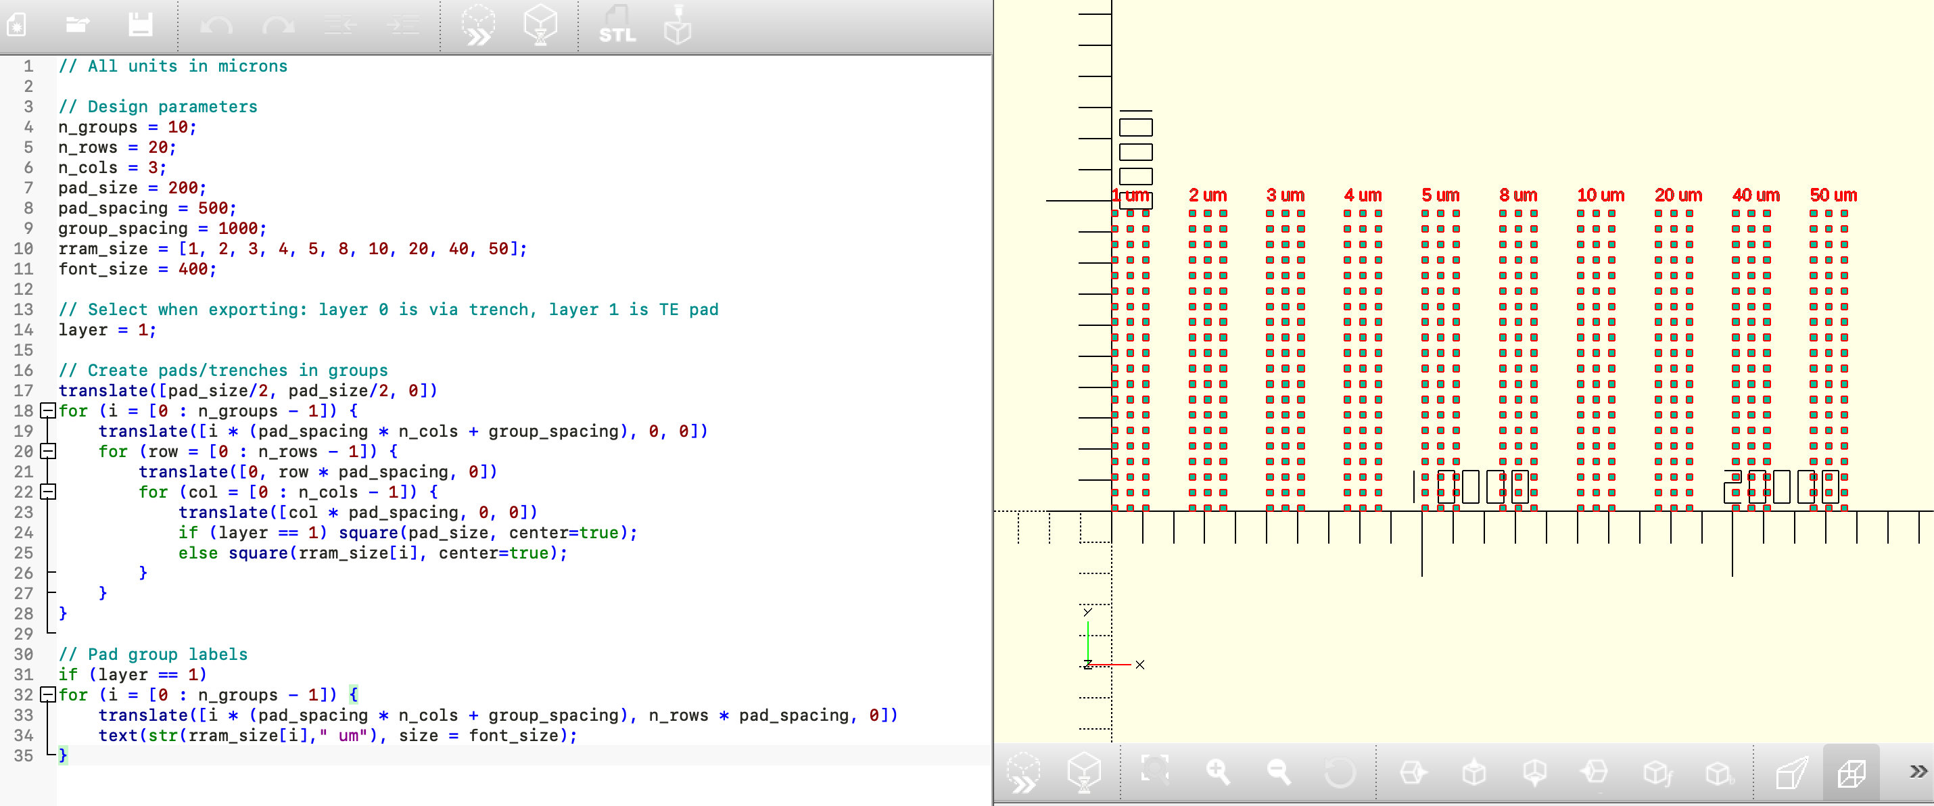



The layouts are parametric, meaning that the design can be adjusted to fit different needs. The list of parameters is given below.

## Layout Parameters

|  |  |
| --- | --- |
| n_rows | Number of rows per stack |
| n_cols | Number of columns per stack |
| pad_size | Width of a contact pad |
| pad_spacing | Vertical/horizontal spacing between pads |
| group_spacing | Horizontal spacing between groups of pads |
| rram_size | Array of different device sizes to test |
| font_size | Size of font for device size labels |
| design_rows | Number of rows to replicate by |
| design_cols | Number of columns to replicate by |

The best way to truly understand what a parameter does is to use OpenSCAD and adjust it to see how it affects the design.

# Electrical Testing Methodology and Device Characteristics

The devices were tested on the micromanipulator6000 (part of nSIL). We experimentally adjusted the electrical test parameters to allow the devices to be cycled non-destructively. In particular, we discovered that FORMing without a 1MΩ resistor caused our devices to be permanently shorted. We also found that devices that were SET/RESET with too high a voltage or too long a delay would be permanently shorted. In many devices, we discovered strange behavior that can probably be attributed to shortcomings in our process flow. In particular, we believe that: (1) SiOx from the trench sidewalls was causing anomalous switching behavior and resulting in multiple possible filament paths (see anomalous switching section for more explanation), (2) the TiN was still highly oxygen-contaminated (13% from XPS) resulting in lower concentration of oxygen vacancies, (3) ALD produced too high a thickness for the resistive switching layer (reason unknown). We discuss ways to mitigate these problems in the future work.

## FORMing Sweep Parameters

|  |  |
| --- | --- |
| Measurement.Port.SeriesResistor | 1MOHM |
| Measurement.Primary.Locus | Double |
| Measurement.Primary.Scale | LINEAR |
| Measurement.Primary.Start | 0 |
| Measurement.Primary.Stop | 10 |
| Measurement.Primary.Step | 0.1 |

## FORMing I-V Plots

(Left) Linear scale. (Right) Logarithmic scale.

**FORMing voltage:** 9.1 V

**Post-FORMing resistance @ 100mV:** 8535 Ω

## RESET Sweep Parameters

|  |  |
| --- | --- |
| Measurement.Primary.Locus | Double |
| Measurement.Primary.Scale | LINEAR |
| Measurement.Primary.Start | 0 |
| Measurement.Primary.Stop | 1.7 |
| Measurement.Primary.Step | 0.05 |
| Measurement.Primary.Compliance | 0.002 |

## SET Sweep Parameters

|  |  |
| --- | --- |
| Measurement.Primary.Locus | Double |
| Measurement.Primary.Scale | LINEAR |
| Measurement.Primary.Start | 0 |
| Measurement.Primary.Stop | 1.8 |
| Measurement.Primary.Step | 0.1 |
| Measurement.Primary.Compliance | 0.001 |

## SET/RESET Cycling I-V Plots

(Left) Linear scale. (Right) Logarithmic scale. 6 SET/RESET cycles shown.

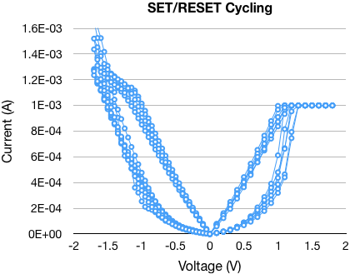 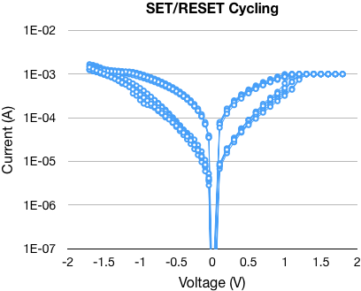

**Approximate SET Voltage:** 1V

**Approximate RESET Voltage:** -1.2V

## SET/RESET Cycling I-V Resistance vs. Cycle

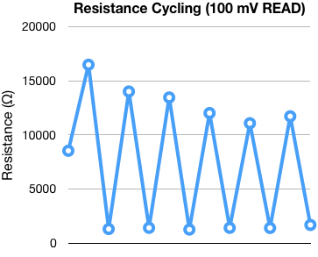 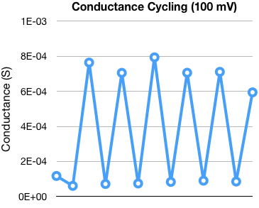

**ON/OFF Ratio:** 7-10x

**Mean OFF Resistance:** 13.1 kΩ

**Mean ON Resistance:** 1.41 kΩ

**Mean OFF Conductance:** 77.5 μS

**Mean ON Conductance:** 712.6 μS

## Anomalous Switching Plot

(Left) Linear scale. (Right) Logarithmic scale. The numbers indicate the order in which the sweeps were performed. On sweep 1, there is evidence of multiple switching events occurring. First the current decreases at -1V (RESET-like event), then there is a steep increase at -1.3V (SET-like event), and then another steep increase around -1.5V. The overall behavior appears to be that of several resistive switching devices with different threshold voltages in series/parallel. On sweep 3, we also notice that the behavior indicates that reversing the bias in an attempt to SET the device results in further RESET (sweep 4 shows the current has decreased further). All of this is anomalous behavior for an RRAM cell and indicates that there may be multiple filament paths (most likely formed through the SiOx sidewalls, since SiOx has also been shown to exhibit resistive switching). The FORMing behavior presented earlier also shows evidence of multiple breakdown events.

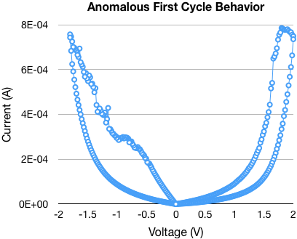 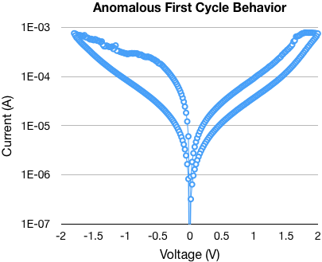

Evidence of multiple switching events

3

4

2

1

# Future Work

## Process Improvements

* Switch to SiNx spacer
  + As a passivation layer for microchips, it is superior to silicon oxide, as it is a significantly better diffusion barrier against water molecules and sodium ions, two major sources of corrosion and instability in microelectronics[1]
  + Better insulator than SiOx and not as susceptible to resistive switching
* Use thicker TiN layer
  + 40nm means that the trench is not completely filled, therefore sidewall coverage may become an issue
  + For good electrical contact, sidewalls of the trenches should be covered
  + So sidewall coverage is an issue that needs to be investigated
* Use reactively sputtered TiN
  + The rationale for this is discussed in the TiN SOP in more detail
  + Reactively sputtered TiN should have lower oxygen contamination and better properties for RRAM overall
* Introduce Ti reactive layer for bottom contact
  + This is used in all state-of-the-art devices to induce robust bipolar resistive switching while suppressing unipolar resistive switching
* Use thinner oxide layer
  + This should greatly reduce the FORMing voltage
* Try using e-beam lithography for ultra-scaled devices
  + So far, the devices have scaled down to 1µm x 1µm with Heidelberg
  + Would be good to try 50nm x 50nm

## Other Steps

* Device qualification process
* Statistical data across multiple working devices
* Process optimization with DOE tool like JMP

## Research Directions

* Test with other resistive switching materials
  + AlOxNy
  + SiOx, WOx, TaOx
  + Chalcogenides e.g. GeTe
* Crossbar layouts instead of blanket metal bottom electrodes

1. Pierson, Hugh O. (1992). [*Handbook of chemical vapor deposition (CVD)*](https://books.google.com/books?id=NF3W6zlN9WsC&pg=PA282). William Andrew. p. 282. [ISBN](https://en.wikipedia.org/wiki/International_Standard_Book_Number) [978-0-8155-1300-1](https://en.wikipedia.org/wiki/Special:BookSources/978-0-8155-1300-1).